**Project Part I:**

**All the groups, who were assigned Cloud infrastructure tools, split your group into two subgroups, maximum 3 people or minimum 2 can be in a group. Both sub-groups will work on developing Cloud Computation Distinct applications (Computation, Storage, Communication, or any processing etc.) using the same assigned tool.  
A member from each group will submit a report for their distinct task with following requirements.   
0: Title   
1: Introduction:  
2: Tools Specification with diagram or architecture:  
3: The Description of techniques or configuration of tool/component  group is going to implement, step by step.  
4: Result/ Output discussion with output diagram or visualization.  
5: References  
Maximum 6-7 pages are enough excluding title page.  
*Each group will give project demo in office.***

**Cloud Infrastructure**

1. Describe the following component in AWS Cloud Infrastructure.

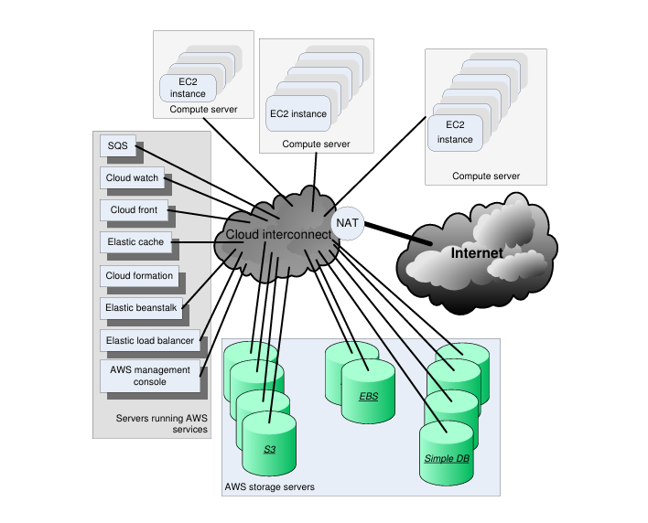

1. Describe the following component in Windows Azure.

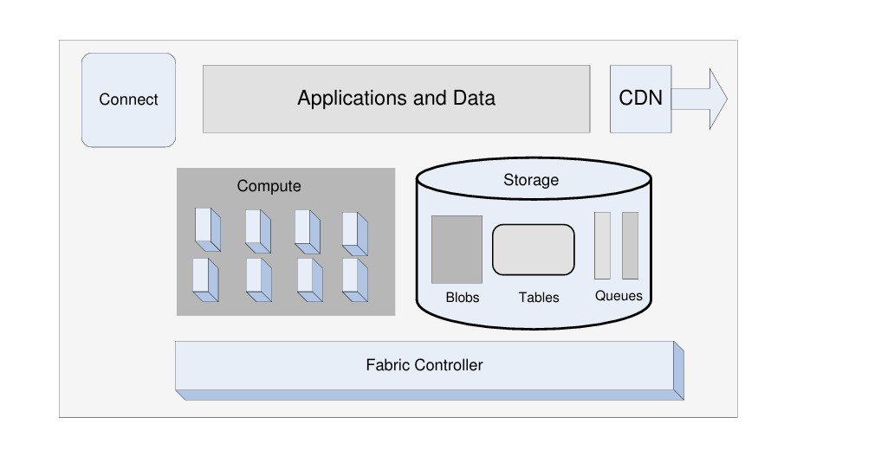

1. Briefly describe RAID [0-5]. Give details of RAID5 configuration in cloud service as storage service to avoid Vendor-lock-in.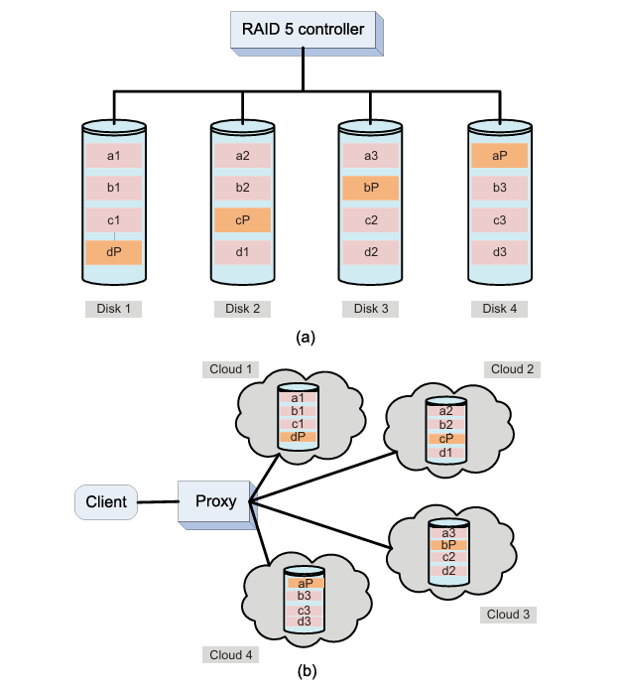
2. Describe the Eucalyptus Open-source software Platforms for Private Cloud.

